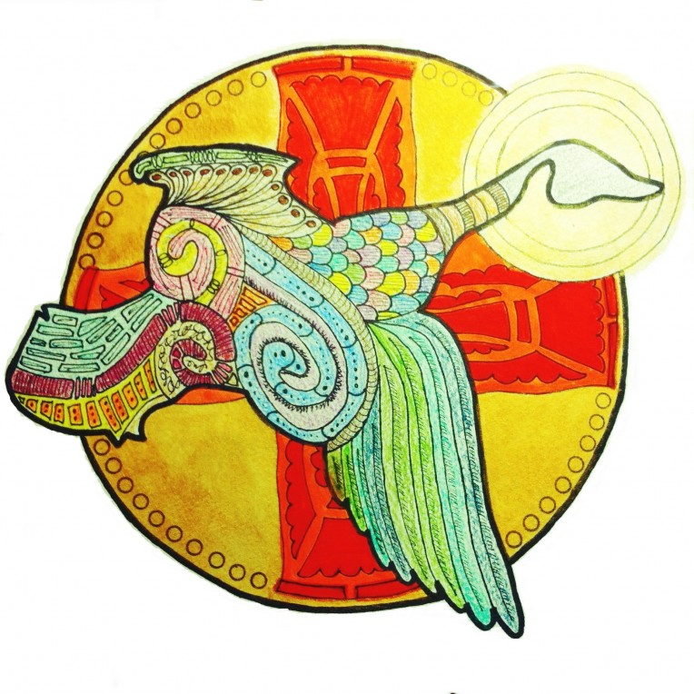**Celtic Evensong & Communion**

May 20, 2018 - 5:30 p.m.

Community of Faith United Methodist Church

Pentecost Sunday

*Celtic Christians chose the Wild Goose as a way to talk about the Holy Spirit. Celtic Christians often forged their symbols out of the ordinary, daily things of the earth that they saw in front of them. For them, the untamed, uncontrollable, erratic nature of the Wild Goose more closely characterized the movement of the Spirit than did a peaceful, tranquil Dove. A Wild Goose is always on the move, always doing unexpected things; it is loud, passionate, sometimes frightening, and certainly unsettling. This has been more like my experience of the Spirit than the peaceful, tranquil Dove.*

*Welcome. To prepare for worship and allow for private prayer, we ask that silence be observed upon entering and that you turn off cell phones. Offering plates are not passed through the congregation at this service but are located at the entrances to the church and the offering will benefit the Food Distribution Ministry. We are aware that persons here come from several faith traditions and are delighted for your presence. The mixture of faith traditions that makes up this community are cherished. We are glad you are here.*

**PRELUDE**

**GATHERING THOUGHTS** *An Geadh-Glas (Wild Goose)* Sally Coleman

I feel the

Beat of your wings

Stirring the air

Around me,

Awakening my slumbering spirit,

Calling me . . .

To rise

To follow . . .

I hear your call,

Behind me, and

Before me,

The call of adventure,

The call to fullness

Of life!

Free me O Wild One,

From these chains

Of complacency

And the shackles of comfort I have made.

Free me O Wild One

For I choose to

Release my heart, and

To follow you again.

Stir me,

Call me,

Free me,

Release me.

Come O Wild One,

Come.

May it be so. Amen.

**OPENING RESPONSES** St. Augustine of Hippo (AD 354-430)

Breathe in me O Holy Spirit

**that my thoughts may all be holy;**

Act in me O Holy Spirit

**that my works, too, may be holy;**

Draw my heart O Holy Spirit

**that I love but what is holy;**

Strengthen me O Holy Spirit

**to defend that is holy;**

Guard me then O Holy Spirit

**that I always may be holy.**

**HYMN** *Come and Find the Quiet Center The Faith We Sing #*2128

1. Come and find the quiet center in the crowded life we lead,

find the room for hope to enter, find the frame where we are freed:

Clear the chaos and the clutter, clear our eyes that we can see

all the things that really matter, be at peace, and simply be.

2. Silence is a friend who claims us, cools the heat and slows the pace,

God it is who speaks and names us, knows our being, touches base,

making space within our thinking, lifting shades to show the sun,

raising courage when we're shrinking, finding scope for faith begun.

3. In the Spirit let us travel, open to each other's pain,

let our loves and fears unravel, celebrate the space we gain:

There's a place for deepest dreaming, there's a time for heart to care,

in the Spirit's lively scheming there is always room to spare.

**A PRAYER FOR THE EVENING** Sister Joan Chittister

May the Gifts of the Holy Spirit

## bring fire to the earth

## so that the presence of God

## may be seen in a new light,

## in new places, in new ways.

## May our own hearts burst into flame

## so that no obstacle, no matter how great,

## ever obstructs the message of the God within each of us.

## May we come to trust the Word of God in our heart,

## to speak it with courage,

## to follow it faithfully

## and to fan it to flame in others.

## May the Jesus who filled all

## with his Holy Spirit

## fill the world and the church

## with new respect

## for women’s and children’s power and presence.

## Give me, Great God, a sense of the Breath of Spirit within me as I……

## (State the intention in your own life at this time for which you are praying in silence.)

## Amen

## SCRIPTURE READING Acts 2:1-21

When the day of Pentecost had come, they were all together in one place. 2And suddenly from heaven there came a sound like the rush of a violent wind, and it filled the entire house where they were sitting.3Divided tongues, as of fire, appeared among them, and a tongue rested on each of them. 4All of them were filled with the Holy Spirit and began to speak in other languages, as the Spirit gave them ability.

5Now there were devout Jews from every nation under heaven living in Jerusalem. 6And at this sound the crowd gathered and was bewildered, because each one heard them speaking in the native language of each.7Amazed and astonished, they asked, “Are not all these who are speaking Galileans? 8And how is it that we hear, each of us, in our own native language? 9Parthians, Medes, Elamites, and residents of Mesopotamia, Judea and Cappadocia, Pontus and Asia, 10Phrygia and Pamphylia, Egypt and the parts of Libya belonging to Cyrene, and visitors from Rome, both Jews and proselytes, 11Cretans and Arabs—in our own languages we hear them speaking about God’s deeds of power.” 12All were amazed and perplexed, saying to one another, “What does this mean?” 13But others sneered and said, “They are filled with new wine.”

14But Peter, standing with the eleven, raised his voice and addressed them, “Men of Judea and all who live in Jerusalem, let this be known to you, and listen to what I say. 15Indeed, these are not drunk, as you suppose, for it is only nine o’clock in the morning. 16No, this is what was spoken through the prophet Joel: 17‘In the last days it will be, God declares, that I will pour out my Spirit upon all flesh, and your sons and your daughters shall prophesy, and your young men shall see visions, and your old men shall dream dreams. 18Even upon my slaves, both men and women, in those days I will pour out my Spirit; and they shall prophesy.19And I will show portents in the heaven above and signs on the earth below, blood, and fire, and smoky mist. 20The sun shall be turned to darkness and the moon to blood, before the coming of the Lord’s great and glorious day. 21Then everyone who calls on the name of the Lord shall be saved.’

## *Silence is observed after the reading*

**REFLECTION**

**MUSIC**

**PRAYER UPON THE EVENTS AT SANTA FE HIGH SCHOOL, TEXAN**

Have mercy upon us, most holy God, Source of all being, all hope, and all life. *Silence is kept briefly.*

We confess to you, O God, our worship of unholy things fashioned not by you, but by our own hands.

**Lord, have mercy.**

We confess to you our fascination with those guns and weapons that claim the lives of the undefended and the vulnerable, especially of children wounded and killed in acts of random terror.

**Lord, have mercy.**

We confess to you our attachment to the means of violence and bloodshed, and our idolatry in claiming that they alone can save us.

**Lord, have mercy.**

We confess to you that we have allowed our hearts to be misshapen by media that glorify violence and trivialize human life.

**Lord, have mercy.**

We confess to you our lack of courage and clarity in public policy, choosing individual rights over the common weal.

**Lord, have mercy.**

We confess to you the poverty of our response to gun deaths among people of color and our lack of the outrage that we reserve for the slaughter of white children.

**Lord, have mercy.**

Hear us, good Lord and God of all creation, and grant us the grace to build more loving households, to be more caring neighbors, to fund and equip our schools more generously, and to hear in our hearts your message of love and forgiveness.

**Hear us, good Lord.**

Unfetter us, O God of deliverance, from the grip of the unholy trinity of poverty, racism, and guns.

**Hear us, good Lord.**

Guide us, O God of the prophets, in the difficult conversations about what truly drives our fears.

**Hear us, good Lord.**

Protect, O God our Sun and Shield, those whom you have called to speak the truth to the powerful and the contented.

**Hear us, good Lord.**

Help us, O God of Shalom, to dwell peacefully and boldly in your Holy Name, that the militias of hatred and fear will step back and fall to the ground.

Hear us, good Lord.

Lord, have mercy.

**Christ, have mercy.**

Lord, have mercy.

Eternal God, in whose perfect reign no weapon is drawn but the sword of righteousness,

no strength known but the strength of love: Guide us with your cloud by day and your fire by night, and grant us wisdom and courage for the facing of this hour. All this we ask for the sake of your love.

**Amen.**

**MUSIC FOR MEDITATION**

*During the instrumental, the hymn and at any time hereafter,*

*you are welcome to come forward to light a votive candle as a symbol of your prayer.*

*Tapers and votive candles are in front of the chancel step as well as behind the chairs.*

*Please free to go to any of these places to light a candle.*

**HYMN** *Look Well Within* Tune: Calm Seas

**

**THE GRACE** Luke 6:35-38a

Love your enemies, and do good, expecting nothing in return. Be merciful, just as God is merciful. Do not judge, and you will not be judged; do not condemn, and you will not be condemned. Forgive, and you will be forgiven. Amen.

**THE PEACE**

Christ, the Good Shepherd, bind us with a bond of love that cannot be broken. My sisters and brothers, the peace of our Lord Jesus Christ be with you. **And also, with you.**

*The ministers and people greet one another in the name of the Lord.*

*After exchanging the Peace, please be seated.*

**HOLY COMMUNION**

**THE GREAT THANKSGIVING**

*Offering plates are not passed through the congregation at this service. Offering plates are located at the entrances to the church and the offering will benefit the Food Distribution Ministry.*

The Lord be with you.

***And also with you.***

Lift up your hearts.

***We lift them up to the Lord.***

Let us give thanks to the Lord our God.

***It is right to give our thanks and praise.***

We praise you and we bless you, holy and gracious God, source of abundant life. From before time you made ready the creation. Your Spirit moved over the deep and brought all things into being. You made us in your image and taught us to walk in your ways. But we rebelled against you, and wandered far away; and yet, as a mother cares for her children, you would not forget us. Time and again you called us to live in the fullness of your love. And so we join with Saints and Angels in the chorus of praise that rings through eternity, lifting our voices to magnify you as we sing:

***Holy, holy, holy Lord, God of power and might,***

***heaven and earth are full of your glory. Hosanna in the highest.***

***Blessed is the one who comes in the name of the Lord. Hosanna in the highest.***

To deliver us from the power of sin and death and to reveal the riches of your grace, you looked with favor upon Mary, your willing servant, that she might conceive and bear a son. Living among us, Jesus loved us. He broke bread with outcasts and sinners, healed the sick, and proclaimed good news to the poor.

On the night before he died for us, Jesus was at table with his friends. He took bread, gave thanks to you, broke it, and gave it to them, and said: *"Take, eat: This is my Body, which is given for you. Do this for the remembrance of me."*

As supper was ending, Jesus took the cup of wine. Again, he gave thanks to you, gave it to them, and said: *''Drink this, all of you: This is my Blood of the new Covenant, which is poured out for you and for all for the forgiveness of sins. Whenever you drink it, do this for the remembrance of me."*

Now gathered at your table and remembering Christ, crucified and risen, we offer to you our gifts of bread and wine, and ourselves, a living sacrifice. Pour out your Spirit upon these gifts that they may be the Body and Blood of Christ, and make us the Body of Christ given for the world you have made. In the fullness of time bring us from every tribe and language and people and nation, to feast at the banquet prepared from the foundation of the world. Through Christ and with Christ and in Christ, in the unity of the Holy Spirit, to you be honor, glory, and praise, for ever and ever. **AMEN.**

**THE LORD’S PRAYER** from the New Zealand Prayerbook

Eternal Spirit,

Earth-maker, Pain-bearer, Life-giver,

Source of all that is and that shall be,

Father and Mother of us all,

Loving God, in whom is heaven:

The hallowing of your name echo through the universe!

The way of your justice be followed by the peoples of the world!

Your heavenly will be done by all created beings!

Your commonwealth of peace and freedom

sustain our hope and come on earth.

With the bread we need for today, feed us.

In the hurts we absorb from one another, forgive us.

In times of temptation and testing, strengthen us.

From trials too great to endure, spare us.

From the grip of all that is evil, free us.

For you reign in the glory of the power that is love,

now and forever. Amen.

**THE INVITATION**

This is the table, not of the Church, but of the Lord. It is made ready for those who love him and for those who want to love him more.

So, come, you who have much faith and you who have little, you who have been here often and you who have not been here long, you who have tried to follow and you who have failed.

Come, because it is the Lord who invites you. It is his will that those who want him should meet him here.

**THE GIVING OF BREAD & CUP**

*All are welcome to come forward to receive Communion.*

*Gluten free bread is available by asking the celebrants.*

**MUSIC DURING COMMUNION**

**PRAYER AFTER COMMUNION**

God of abundance, you have fed us with the bread of life and cup of salvation; you have united us with Christ arid one another; and you have made us one with all your people in heaven and on earth. Now send us forth in the power of your Spirit, that we may proclaim your redeeming love to the world and continue forever in the risen life of Christ our Savior. Amen.

**BLESSING** Paraphrase of Henri Frederic Amiel

Life is short, and we do not have much time to gladden the hearts of those who are traveling the journey with us. So be swift to love, and make haste to be kind, and the blessing of God be with you always. Amen.

**HYMN** *Go My Children Ar Hyd y Nos*

**A picture containing receipt, text

Description generated with very high confidence**

**DISMISSAL**

*Go out into the world in peace, have courage, hold on to what is good, return no one evil for evil, strengthen the faint-hearted, support the weak, help the suffering, honor everyone, love and serve God, rejoicing in the power of the Spirit.*

**POSTLUDE**

***\*\*\*\*\*\*\*\*\*\*\*\*\****

A cut in half

Description generated with high confidenceWelcome to this time of worship. Community of Faith holds a Celtic Evensong Service the third Sunday of each month with the exception of June-July-August. Contemplative worship experiences are offered twice a month in our neighborhood as our neighbors at Epiphany Episcopal hold a service the first Sunday of the month at 5:30 PM.

*Sunday worship at Community of Faith is at 8:30 AM and 10:30 AM. All are welcome.*

*Acknowledgments*: The Prayer for the Evens of Santa Fe is adopted from a prayer by the Episcopal Bishop of New Hampshire upon the gun violence at Newtown, MA

Celebrant: The Rev. Rob Vaughn

Musicians: Mary Ann East; *First Light Ensemble* consisting of Sharyn Byer (flute), Claire Smith (flute) and Alexandra Molnar-Suhajda (harp)

Do not be daunted by the enormity of the world's grief.

Do justly, now. Love mercy, now.

Walk humbly, now.

You are not obligated to complete the work,

but neither are you free to abandon it.

*The Talmud*

***Ministers - The Entire Congregation***

*Lay Leaders* – Greg Carter,Rory Maynard; *Music Director:* Mary Ann East

***Community of Faith United Methodist Church***

******13224 Franklin Farm Rd. Herndon, VA 20171-4034 Phone: 703-620-1977

E-Mail: [Office@cofumc.org](mailto:Office@cofumc.org) Web Site: [www.cofumc.org](http://www.cofumc.org)

*Rev. Rob Vaughn,* Cell 703-283-2153